Ilex manual

Introduction
The new cross-platform version of Ilex runs under Excel and Illustrator CS. So both applications must be installed on your workstation.
Basically you open and process a Research file under Excel, which will prompt you for chart size, scale values, etc.
You will be dumped into Illustrator, where you use a menu command to draw the chart.
Other commands available in Illustrator allow you to save finished charts to the CCI folder, and to process Indicators tables.

Installation
To install or upgrade, find and open the file “Install Ilex.xls”. This can currently be found in the folder:
/AppleTalk_share/Artserv/GRAPHICS/Ilex master/
Excel will open. If asked, click “Enable macros”.
Basically you can say “OK” or “Yes” to a series of prompts. At the end of the process, Excel will close.

Excel Ilex
To launch Ilex, run the Excel file “Ilex.xls. If asked, click “Enable macros”.
Please note: there is a known bug in the Macintosh implementation of Excel which means that it is impossible to tab from field to field in a User Form (dialog box). You will have to click on fields with your mouse in order to edit them.

Paths
Ilex needs to access various folders across the network. At launch, the first thing it does is check that it can find these. If it can’t, it will complain. The most likely reason will be that a volume is not mounted. If you see a dialog box like this --
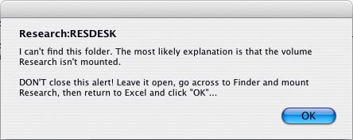
don’t close it. Transfer to Finder and mount the volume; then go back to the dialog box in Excel and now click “OK”.
When Ilex feels safe and secure in its own world, it will display the --

Main form
This is the front end from which you open Research files for processing.

Resdesk
Click to find and open a new Research file. Processing will proceed to the Style form…

Resprd
Click to find and reopen a Research file. Processing will proceed to the Style form…

Reflow
If you get to Illustrator and don’t like the look of the result – say you chose a bar chart, when you really wanted a column chart – go back to Excel and click this button. It will allow you to run through the sequence of forms without having to find and reopen the data file; and it will keep the same values in the various fields…

Hide
This closes the Ilex window and leaves you in Excel. Select “Resume Ilex” from Excel’s Tools menu to relaunch Ilex…
(You will also be dumped into Excel if Ilex can’t make sense of a Research file. The file will be open, so make changes, save-and-close and relaunch Ilex…)

Paths
Click to change any of the paths Ilex uses. See further below.

Department (aka Current installation)
This determines the overall “departmental” style of which individual section preferences are a subset. At The Economist, “Global Agenda” and “Eco Graphics” are separate departments

User name and phone number
These strings will appear in the details box on the Illustrator page. Edit at will.

Quit
Click to close Ilex and quit Excel.

Sub-section options
After you have “opened” a Resdesk or Resprd chart…
Indicators (“IN”) charts allow you to choose a “sub-section” – a style that defines specific values for the height and width of the chart; for extra space below the title and subtitle; and for the left margin.
When you see the sub-section user form, click on the style you want…
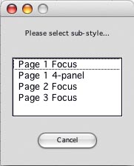
At present, Finance (“FN”) also prompt you to choose between Ec Foc and normal charts.

Style form
The style form opens in front of a worksheet displaying the current data. It is subdivided into three sequential pages:

Page 1
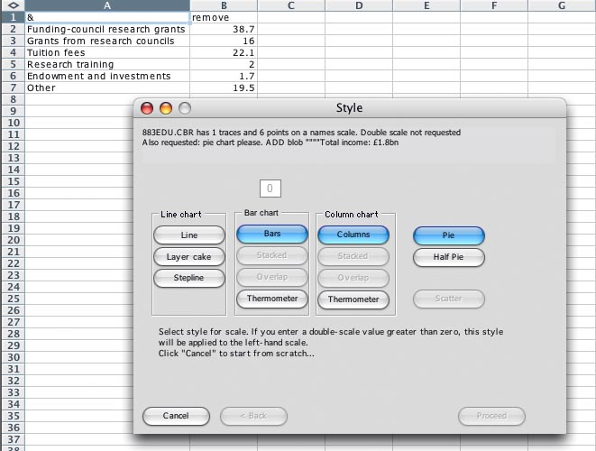
The first thing to decide is whether you want a double scale. In the double scale box (disabled in this screenshot since the chart has only one trace), enter the number of the last trace that should be associated with the left-hand scale.
Click on the style for the chart.

Page 2
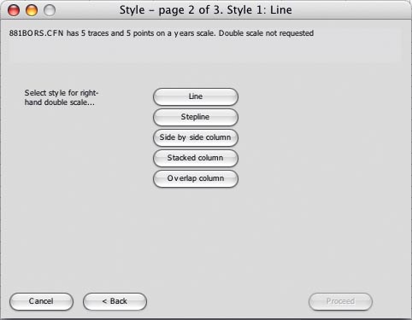
You’ll only see this page if you are drawing a double scale. Click the style for traces linked to the right-hand scale. (Or click “Back” to return to Page 1.)

Page 3
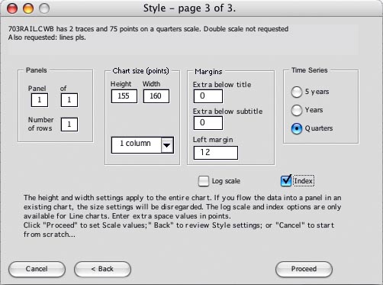
Panels: if you are drawing a multi-panel chart, enter details (these should have been set by Research).
Chart size: enter height and width. Use the columns drop-down to enter widths quickly.
Margins: enter any extra space you want below the chart title or subtitle. You can even close the gap by entering a negative value. You can also change the width of the left margin.
Time series: select a series for the time scale
For line charts you can select a Log scale. Or, if all traces start with a value of 100, you will have to option to index them.
Click “Proceed” to go on to –

Scales form
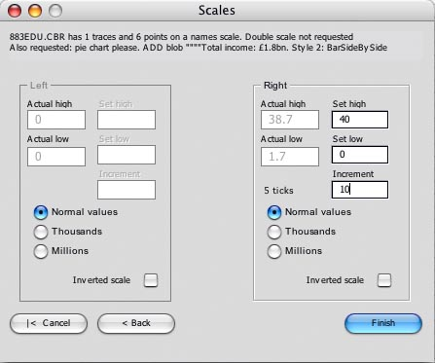
Enter high, low and increment values. If you use a double scale, or if this is a scatter chart, both sets of fields will be enabled.
Use the Thousands or Millions options on either side to divide the values appearing in scale labels by that amount. Ilex will append a label (‘000 or m) to the chart’s subtitle.
Use the Inverted scale option to invert either scale.
If you are drawing a double scale and ticks are drawn right across the chart, the number of ticks on each scale must match.
Click “Finish” to transfer to Illustrator…

Breaking the top of the scale
If you enter a top-of-scale value that is less than the actual high value, you will see this dialog:
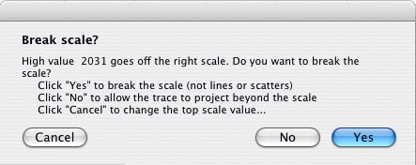
The options are:
- Cancel
This returns you to the Scales form, where you can change your high value…
- No
Any trace point that exceeds the top of the scale will be allowed to project.
- Yes
For line and scatter charts, this is the same as clicking “No” – the trace will project beyond the top of the scale.
Otherwise, for any column or bar that projects beyond the top of the scale, a detached jagged-edged section will be created, with the actual value for that point displayed.

Paths
Clicking the Paths button on the Main form will open the Paths form:
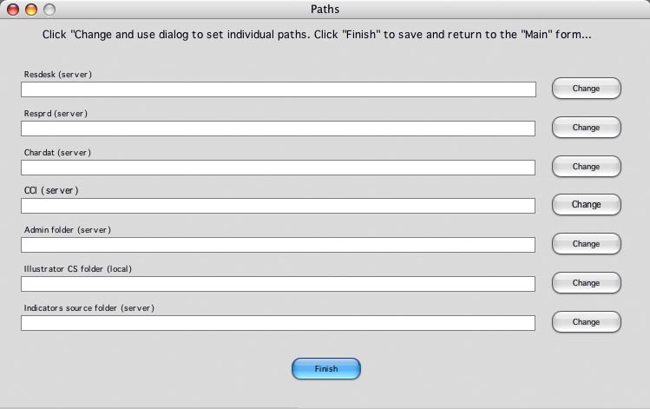
Click the “Change” button beside the path you want to change. When all the paths are right, click “Finish” to save and return to the Main form.

Illustrator
To draw the chart on the page, select the “Ilex” command from the File:Scripts menu –
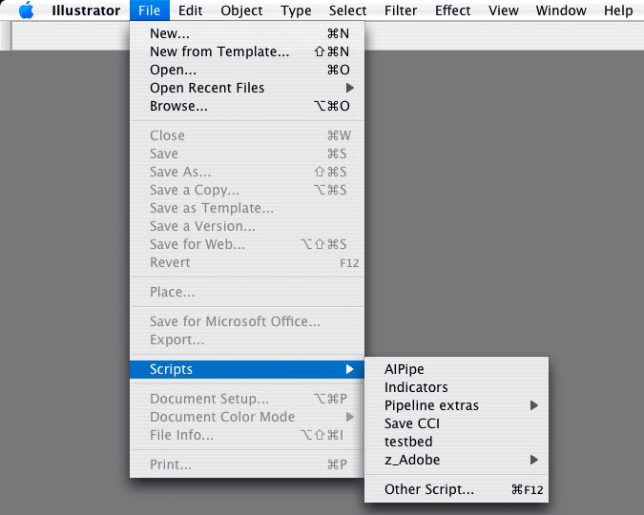
Illustrator will draw the chart on the page. When it’s ready, it will show what it’s done and (according to preference) ask if you want to save either:
- a temporary copy of the file to the Chardat folder, or
- a final copy to the publication database (CCI)
(For Global Agenda, these folders are the same.)
If you like what you see, you should say “Yes”; if you’re dissatisfied, click “No”, close the chart (don’t save the Template) and go back to Excel, where you can use the “Reflow” option (see above) to change the chart…
If you’re happy with the chart, make any changes you want.

Save CCI (Eco Graphics only)
When you’re happy with the chart, use the “Save CCI” command on the File:Scripts menu to print it and save it to the CCI database in-folder.

Multipanel charts
To draw a chart with more than one panel:
- On the first panel you process:
  - In Excel, on page 3 of the Style form (see above) enter three values for the number of the panel, the total number of panels, and the number of rows you want.
(You don’t have to process panel 1 first)
  - Enter the size of the entire chart, including all panels. Continue processing in Excel as normal…
  - In Illustrator, select the “Ilex” command to draw the chart. This will include the number of panels you asked for, one of which will contain the current data.
  - When you are prompted to save the chart, say Yes. Leave it open…
- For subsequent panels:
  - In Excel, import the data from Resdesk or Resprd.
  - On p.3 of the Style form, enter the panel number, total number of panels and number of rows.
  - You can accept the default size, since the overall size of the chart has already been established.
  - In Illustrator, with the chart still open, select the “Ilex” command. The new data should flow into the panel you chose.

Don’t panic
Ilex is not designed to produce 100% page-ready charts, just to make a good stab at it. So expect to do some tweaking by hand. In particular, time scales may look a little strange…
This chart demonstrates an extreme case: an hourly scale. Ilex has drawn the labels on four lines, but left space for only two. Move and combine strings as you see fit.
It has also drawn long ticks for the change of year, with short ones between the hours (no day or month separators appear in this sequence of dates); in this case you would make the hour separators longer by hand…

Indicators
The “Indicators” command is on the File:Scripts menu.
It will display a form prompting you to enter the number (1-10) of the Indicators table you want to import. If you enter “3” or “3a” (lower or upper case) it will process Table 3A; to process the quarterly Table 3B, enter “3b”.
If the data for the table was created more than 24 hours ago, you will be asked to confirm that you want to proceed…
The table may take10 seconds or so to process. Be patient…
A temporary copy of the table will display. Give it a look over – check, in particular that lines haven’t “jumped” a tab stop and wrapped. If/when it’s okay, use the Save CCI command (above) to save the Table to the database.

Other scripts
In the File:Scripts menu, a further sub-menu, Ilex extras, contains four commands:
- Convert trace
This converts a line trace to columns, or vice versa (it won’t work on a bar chart – why would it?).
Just select the line or the group of columns, then invoke this command.
- Number box
This draws a number box at the top right of a chart.
The script will prompt you for a number to go in the box; the default is “?”.
- Pointer
This adds a pointers to one or more sides of a rectangle (it won’t work unless the object has four corners).
Select the rectangle and invoke the command. You will be prompted to enter a numbers (1-4) corresponding to the sides you want to tweak.
- Resize objects
This will reset the size of each object in a collection to the same height and width. It should be useful if you’ve had to stretch or squeeze all the blobs on a scatter or thermometer chart.
Select all the blobs (grouped or ungrouped). You will be reminded of the current height and width of each object and prompted to enter a value (in points) for the new height and width of each…
(If the objects are radically different in size, the script will protest.)

Preferences
Ilex uses two preferences files to determine the attributes of charts:
- General preferences
This file contains settings common to all charts (for example, the copyright string that appears in the details boxes; whether measurements are expressed in mm or points…)
- Section preferences
This file contains section-specific settings (default chart size, font sizes, etc.) There are actually a number of different section preferences files (“AM”, “AS”, BR”…); which file Ilex refers to is determined by the file name.
Both the General and Section Preferences files are edited using another Excel macro file: Preferences.xls (current file is actually called Preferences_013.xls). This lives in the Graphics Administration folder Research/ADMIN/Graph_admin/
To edit preferences, open Preferences.xls. You will see this form:
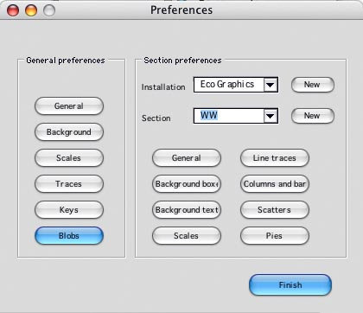

General Preferences
Click any button in the General Preferences column to access that subsection. Once you have started editing General Preferences, you can use the tabs at the top or the buttons at the bottom to move between subsections.
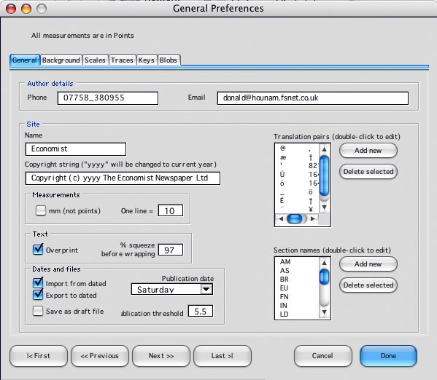
Click “Done” to save changes and return to the front form.

Section Preferences
To come – but the principle is the same as for General Preferences.

